|  |
| --- |
|  |
| Website Design Document |
| Garden Centre Plus  By William Mumby |
|  |
|  |
|  |

|  |
| --- |
|  |

## 1.1 Identification

This document details the Software Design Document (SDD) for the Green Centre Plus website (GCP).

## System Overview

The Garden Centre Plus website is a web application, which has the intended purpose of replacing the old DOS based program, which the Garden Centre is currently using. The primary aim of the Garden Centre Plus website is to allow the business to manage their customer: database, inventory and sales order processing in a more efficient and competent way. It will replace the existing design and functionality that their previous system incorporated, along with offering additional features.

The System will require an employee with Admin rights to initially add someone to the database, before they’re then provided with an employee number, and thus able to create an account and access the features within the website.

The website will provide a number of different functions and features for employees, including:

* Register an account/Log in
* Remote access
* Add, edit, delete and search data
* Place orders
* Check stock levels
* Handle employee and customer details

The website will be simple and understandable to use, with features which greatly consider HCI.

## Document Overview

This document will outline the design for the database that will allow our customer system to persist data throughout its time in use.

# 2. Referenced Documents

|  |  |  |  |
| --- | --- | --- | --- |
| Ref No. | Title | Document ID | Issue |
| 1 | Data Item Description for Software Design Description (MIL-STD-498) | DI-IPSC-81435 | n/a |

# 3. Wide Design Decisions

## 3.1 Database

The database is to be hosted using a simple SQL database and we shall communicate with this database through the Entity Framework tool created by Microsoft.

## 3.2 Web Application

The application that we are building shall be ran on a sever running IIS and also using .NET Framework. This will be written using APS.NET which uses .NET framework hence why it needs to be running on the server. It shall use a bundle of different programming/mark-up languages such as CSS, HTML, JavaScript, Razor and C#. This will follow the MVC Pattern which has three main components explained below:

* Models: These shall contain the data that is going to be manipulated throughout the use creation of the application this also holds the models that will be used by Entity Framework in order to create the databases tables.
* Views: This will be where the mark-up comes in it will use a combination of HTML Razor, CSS and JavaScript in order to provide the user with the views in order to use the application.
* Controllers: This is the part of the application that will be ran server side. This will handle any requests and access the database to provide the user with whatever data is requested. This will also hold most of the security for the application.

In addition to this pattern the web application will make use of view models which will hold data that is only related to the view.

# 4. Architectural Design

## 4.1 Components

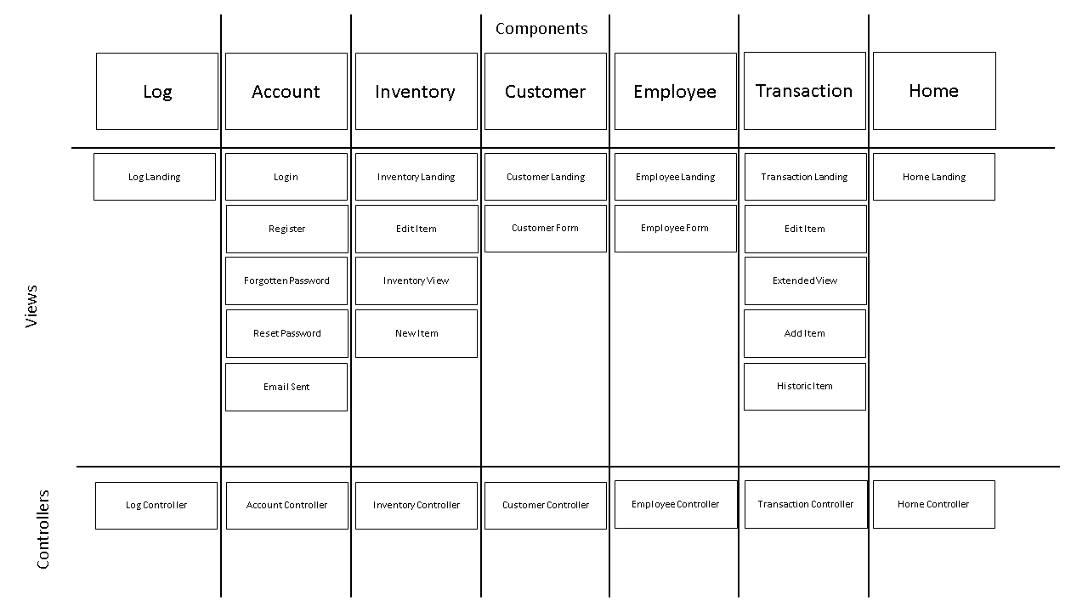

The diagram above illustrates how each part of the website labelled as a component will be split up and wat views will be controlled by what controllers. These will all use the models which can be found in the data dictionary section of the Database Design Document.

### 4.1.1 Log

This is the part of the application where a user who has admin privileges to there account can view all of the actions that have been made by an employee and on what part of the website. This will have displayed in the form of a table. This will display the data based on the latest entries first. The table will also provide the user the ability to search and also page through the data.

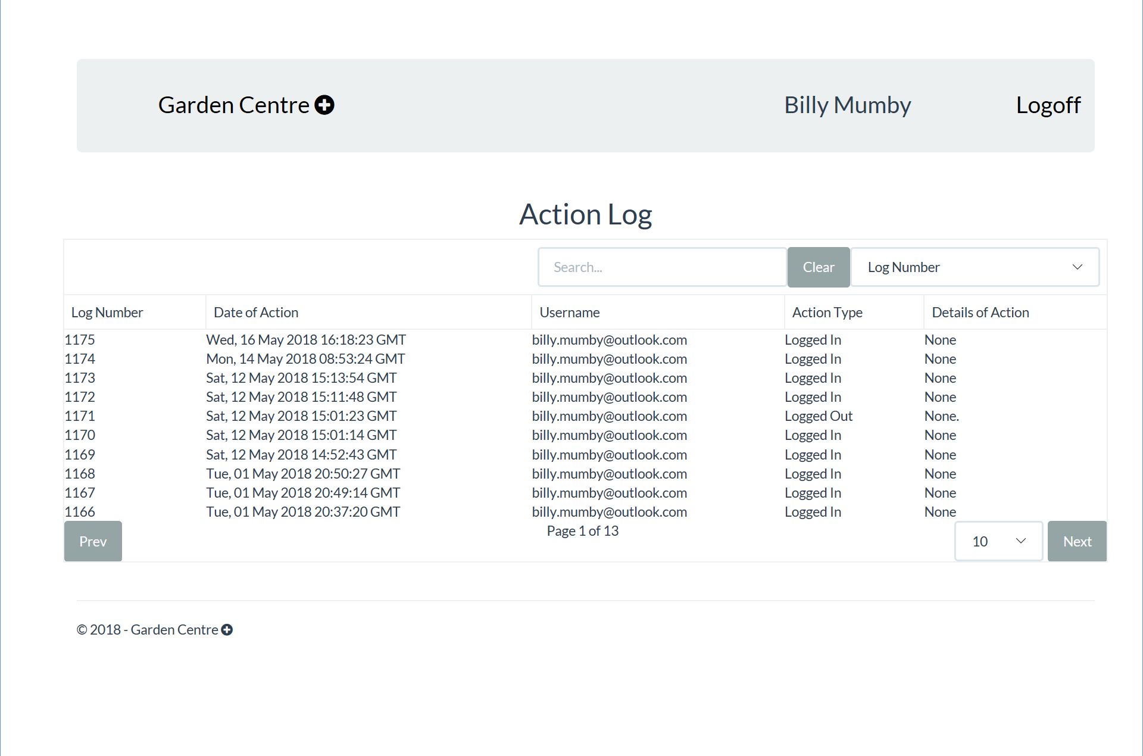

### 4.1.2 Account

This is the part of the website which will give the user the ability to register a new account as well as to login with a existing account. This also a forgotten password section where the user will be sent a link in order for them to access a form where they can reset there password.

#### 4.1.2.1 Login

This is where the user will log into the page it will contain a form where they are to enter there employee number, there email and there password. This will also provide links to the forgotten password page and also the register screen.

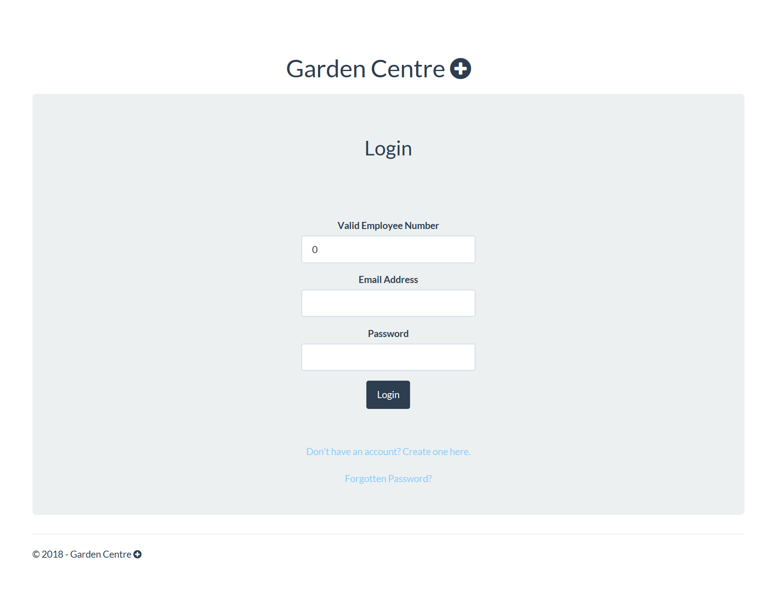

#### 4.1.2.2 Register

This is the part of the website where the user will be able to register their account that will have been provided by there boss. It will contain input fields where the user will enter their employee number, there email and also their password which will have to be confirmed.

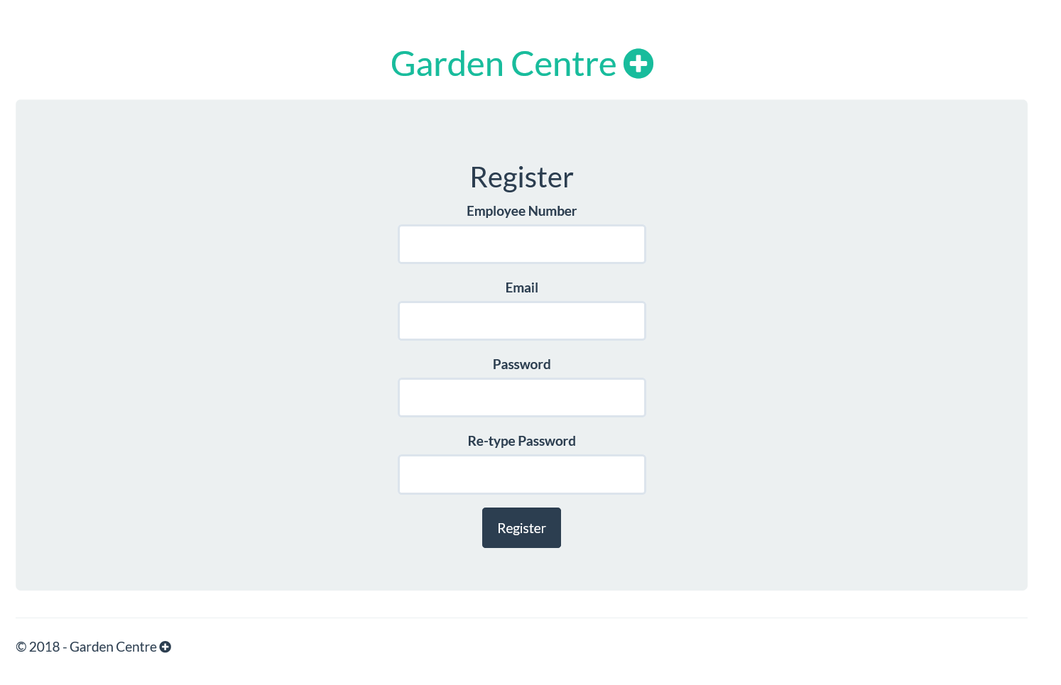

#### 4.1.2.3 Forgotten Password

This is the section of the website can enter there email and employee ID in order for the application to send them a email which will allow them to go to another link where they can reset the password on there account.

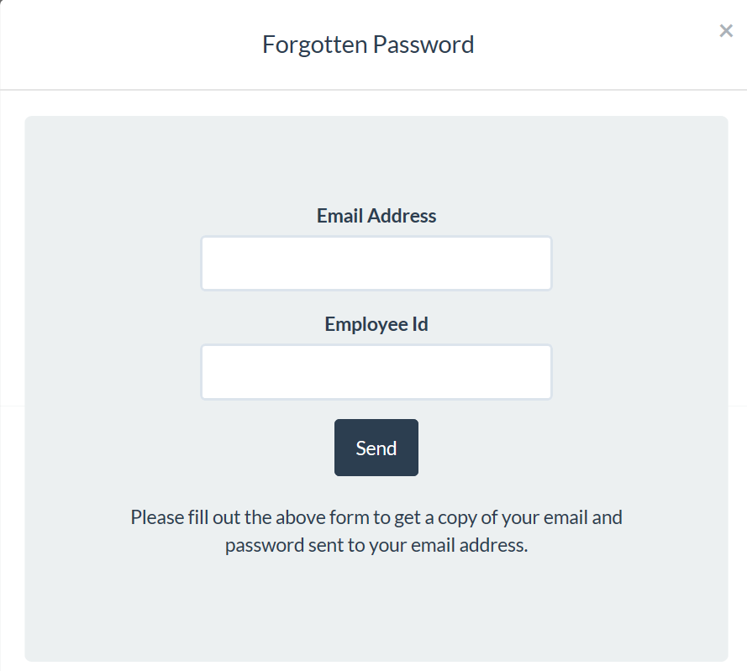

#### 4.1.2.4 Email Sent

This is the view where the user see that an email has been sent and then navigate back to the login page ready to enter there new password.

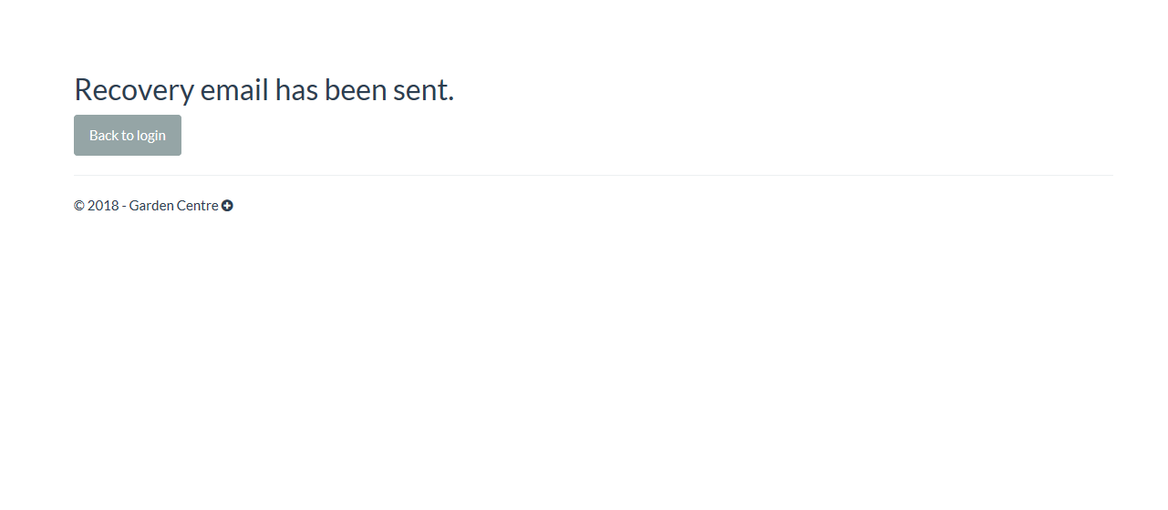

#### 4.1.2.5 Reset Password

This is the page where they user will enter there new password and then confirm once this has been submitted there password will be reset.

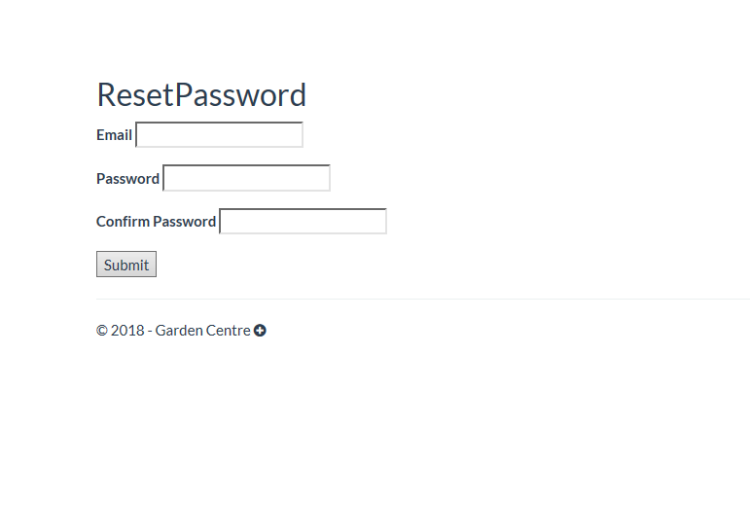

### 4.1.3 Inventory

This is the section of the website where the employees can add edit and delete stock that they have recorded in the system. This has many section which are labelled in the components diagram.

#### 4.1.3.1 Landing Page and Inventory View

This page will contain a table which contains a table with all the items which are in stock it will provide searching and paging like all of the other tables in this application. It will also have links to allow the user to add and edit items.

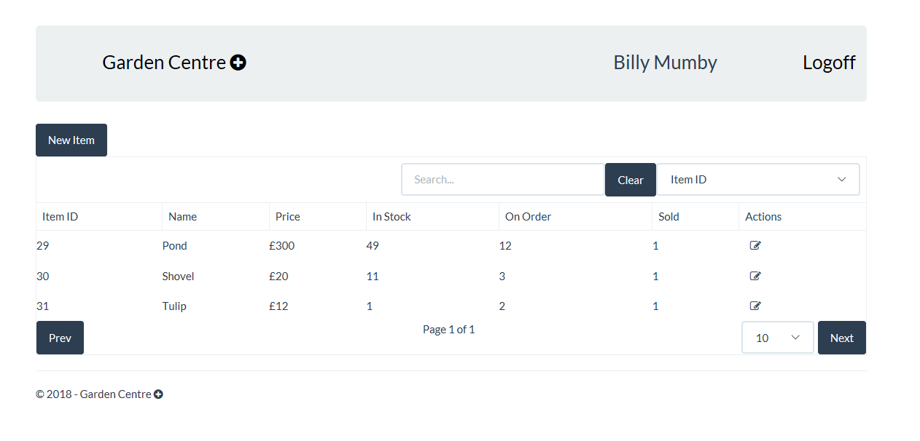

#### 4.1.3.2 New Item

This is the form which will be displayed when we click the new item button which can be seen in the image above. It will allow the user to add a description for the item a price, amount in stock and also amount of items that are on order.

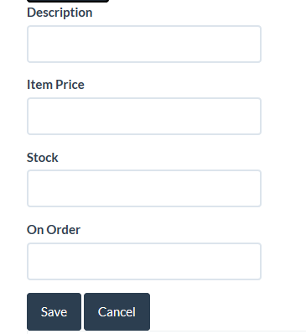

#### 4.1.3.3 Edit Item

This feature has been removed from the website as we do not feel that they should be able to delete a item from the database.

### 4.1.4 Customer

This is the part of the website where they user shall be able to perform all crud operations on a customer.

CRUD stands for Create, Read, Update and Delete

#### 4.1.4.1 Customer Landing

This is the first page that the user will come to when they access the customers link from the home page. This will have buttons that will allow the user to perform all of the CRUD operations as well as viewing all of the customers in the form of a table that again comes with searching and paging.

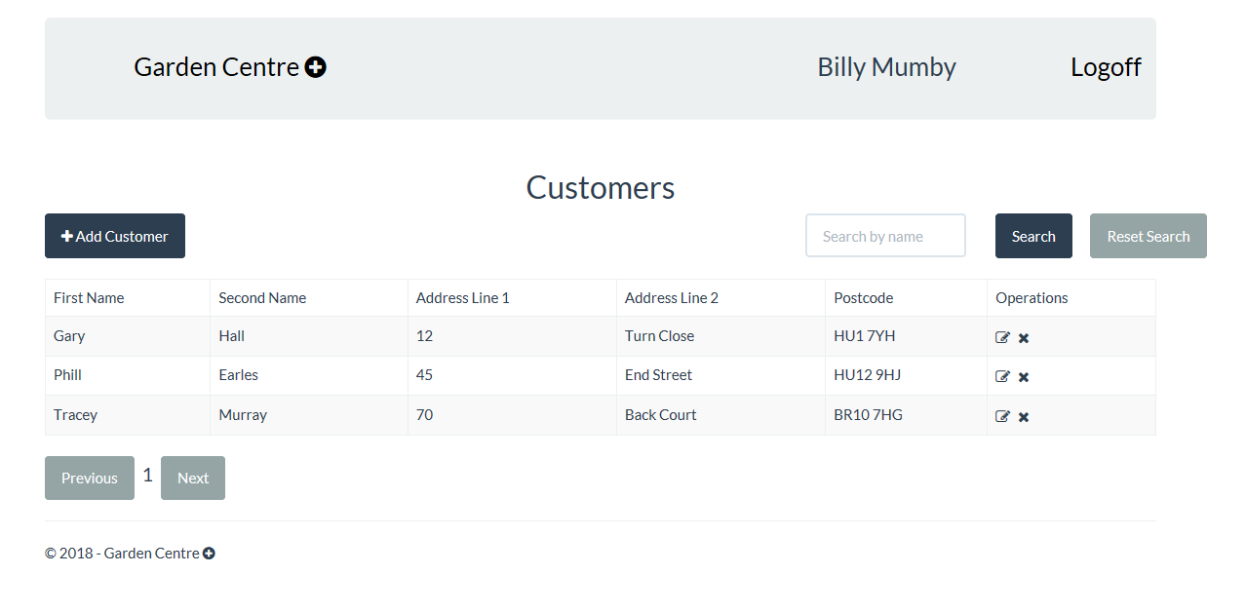

#### 4.1.4.2 Customer Form

This is the form that will be used when a user chooses to either add or edit a customer. The only difference is that it will be pre-populated with data for the user that they have chosen to edit and if they add the form shall be empty. Clicking save shall update the database.

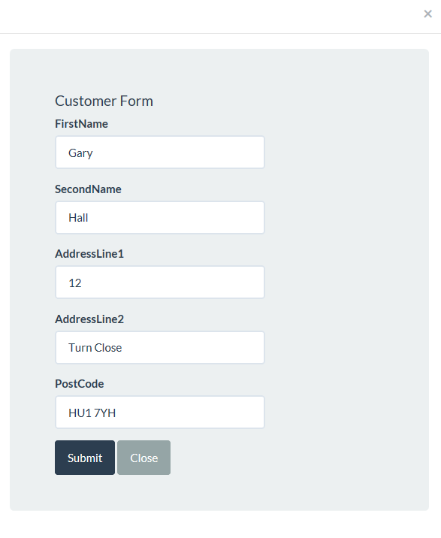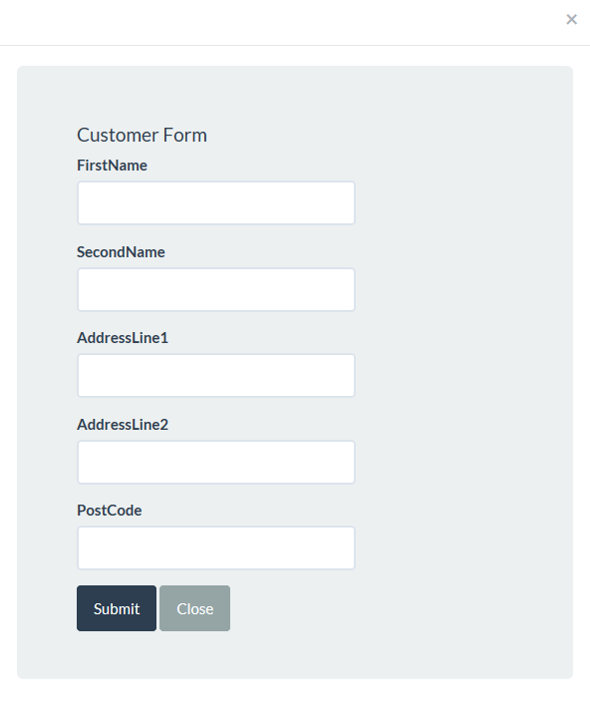

### 4.1.5 Employee

This is the page where the administrative users can add new employees to the system they will land on a page that will allow them to see all the employees that are able to use the system.

#### 4.1.5.1 Employee Landing Page

On this page there will be links to allow the user to add another employee to the system and edit and delete existing ones.

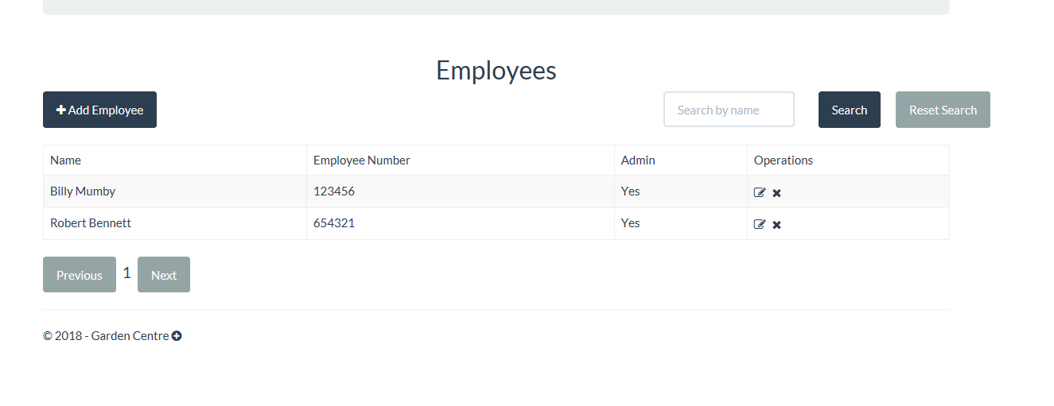

#### 4.1.5.2 Employee Form

This form just as the customers one will be used both for editing and adding a new user, but it will not allow the user to edit a employees number. This will contain a form that will allow them to enter a name and employee number and also if the user is going to have administrator privileges.

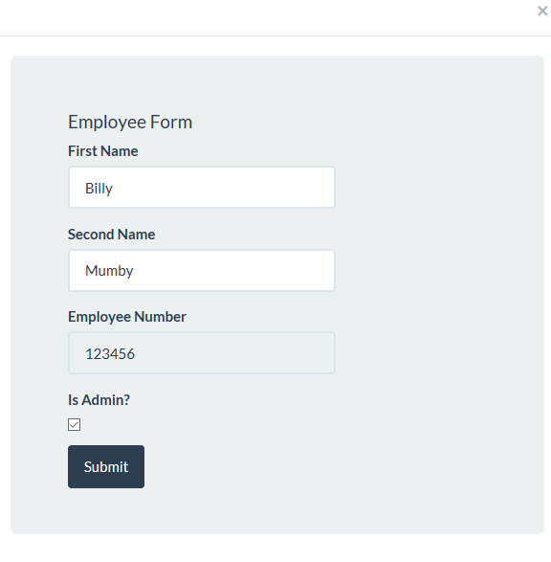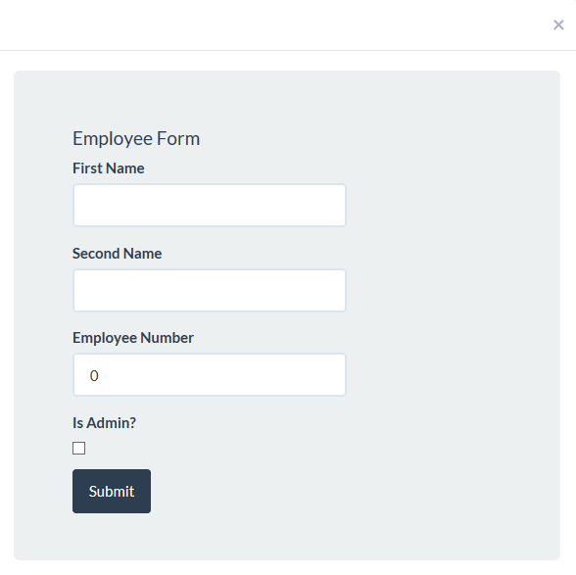

### 4.1.6 Transaction

This is where the employee will be able to go onto the system and log any transactions that have been made throughout the day. It will be in sync with stock so they will not be able to sell any items that are not in stock in system.

#### 4.1.6.1 Landing and Historic View

These two views display the table that again shows latest transactions on the first screen in the form of a table which again provides searching and paging for all transactions made. This will also allow the user to preform CRUD operations on all of these transactions.

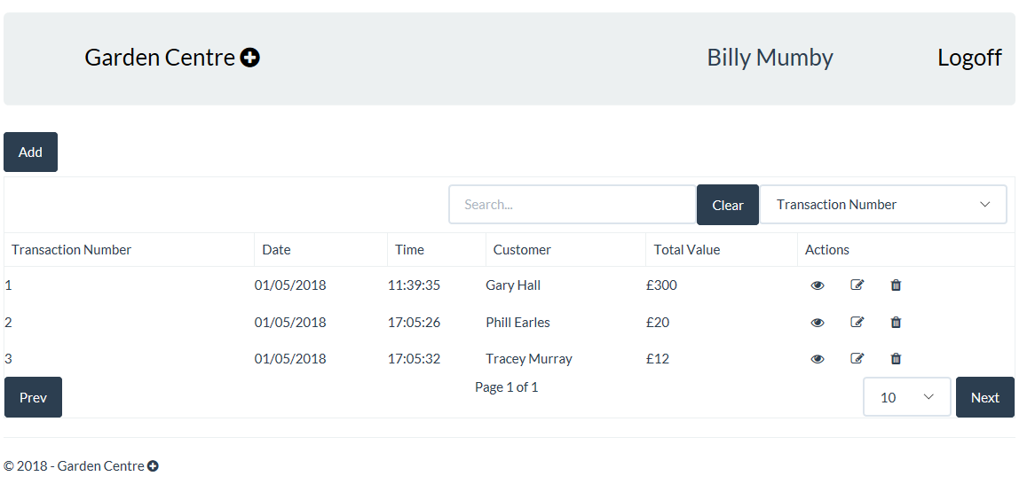

#### 4.1.6.2 Extended View

This is the part of the transaction page which will allow the user to view more information than what is available in the original table it will contain each individual item that was ordered and its price. This will slide down into a new row in the table.

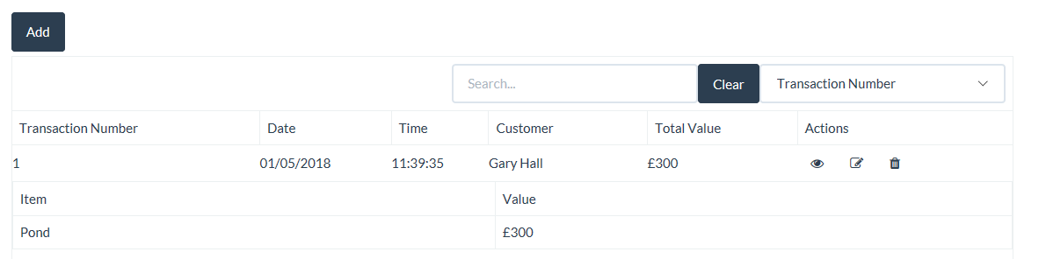

#### 4.1.6.2 Edit View

This works very similar to that of the extended view when the user wants to select a transaction to view but it gives them more options such as to delete a item within that transaction and also to add a new item.

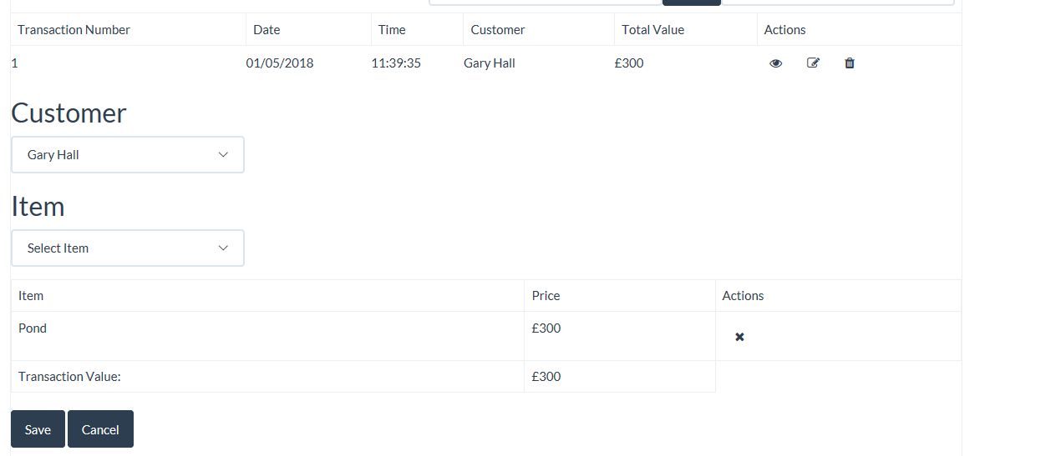

#### 4.1.6.3 Add View

This view will allow the user to add a new transaction they can select a customer and then a item of a combo box which will be added to the transaction table on the bottom of the screen.

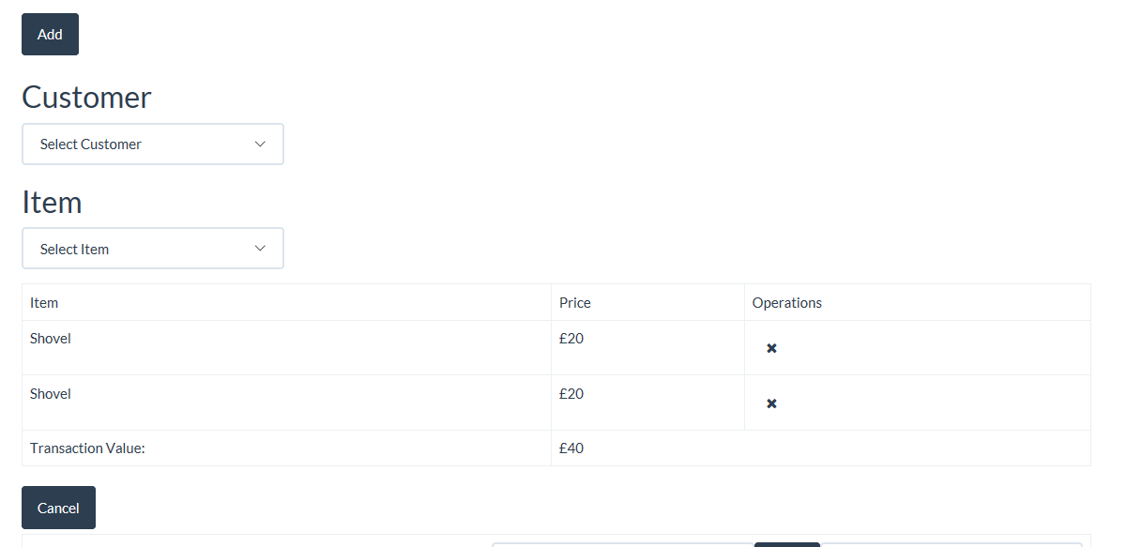

### 4.1.7 Home

This is the splash screen that the user will see as soon as they login. It will provide links to all of the different pages.

#### 4.1.7.1 Home Landing Page

This is the screen which will provide the user with all the links to access all of the other pages in the form of large tiles.

